**Report**

**on**

**FRONT-END ENGINEERING**

**CS186**

by

**Amuljot Singh**

**2110990168**

**G5**

**3rd YEAR**

**INSTRUCTOR’S NAME – MR. LAVISH ARORA**

**Batch 2021**

**Session 2023-24**



**1. Introduction**

* 1. **Product Landing Page**

A product landing page is a web page designed with the purpose of promoting and selling products. Visitors are directed to a product landing page after clicking on a link from a social media post, ad, newsletter, etc.

Landing pages are an important marketing tool. Although there are different types of landing pages, the main purpose is to start people on the trail toward making a purchase.

The most common landing pages are lead generation and product landing pages. Lead generation landing pages are used to gather information from a visitor to make a future sale. Product landing pages are used to make the immediate sale of a product. A combination of the different styles of landing pages can create a page with a higher conversion rate.

**1.1.1 Electronics Landing Page**

The Electronics is a website designed to showcase a variety of electronics, from mobile phones to home appliances. The page is organized in a way that makes it easy for customers to find what they're looking for and make a purchase.

Electronics Website is a product landing website which is specifically designed for the targeted audience which can vary from various age groups and genders.

**2. Problem Statement**

The electronics industry is highly competitive, and it can be challenging to create a

website that stands out from the rest. One of the biggest challenges is creating a

landing page that effectively showcases your products and entices customers to make a purchase. This requires careful consideration of design elements such as color, layout, and typography, as well as a clear understanding of your target audience and their needs.

Another challenge in creating a electronics website is ensuring that it is optimized for search engines. This involves using relevant keywords in your content and meta tags, as well as ensuring that your website is mobile-friendly and has a fast-loading speed. Failure to optimize your landing page can result in low search engine rankings and reduced visibility, which can ultimately lead to lower sales.

**3. Technical details**

The technical details of an electronics website are crucial to its success. One important aspect is the use of high-quality images that showcase the items from multiple angles and in different lighting conditions.

In addition to visual and descriptive elements, there are also technical considerations that must be taken into account.

It should also be designed with mobile devices in mind, as more and more people are using their phones to browse and shop online.

**The Front-End technologies that are used to implement this project are:**



**3.1 HTML**

The Hypertext Markup Language or HTML is standard markup language for documents designed to be displayed in a web browser. Hypertext defines the link between the web pages and markup language defines the text document within the tag that define the structure of web pages.

.



**3.2 CSS**

CSS or cascading style sheets is used for styling and formatting HTML documents. It is used to define styles for HTML elements such as fonts, colors, spacing and layout. It can be used to create a layout — for example turning a single column of text into a layout with a main content area and a sidebar for related information. It can even be used for effects such as animation.

**3.3 Java Script**

JavaScript is a programming language used to add interactivity and functionality to websites. It is commonly used to create dynamic effects, responsive and interactive web pages.  Earlier JavaScript was used to build client-side applications only, but with the evolution of its frameworks namely Node.js and Express.js, it is now widely used for building server-side applications too.

**3.4 VS CODE**

Visual studio code is a free and open-source code editor developed by Microsoft and is designed for building and debugging web and cloud applications. Visual Studio Code is a streamlined code editor with support for development operations like debugging, task running and version control.

.

# 4. Key Features

**4.1 Eye-Catching Homepage:** As soon as visitors land on the homepage, they should be able to get a clear and attractive picture of how to navigate the portal.

**4.2 Easy to Navigate:** The website provides an easy to use, user friendly interface where user can choose and buy various shoe products. Our project has scroll navigation.

**4.3 Compatible and Responsive Website:** Customers will be able to use our website in desktop view as well as tablet view.

**4.4 Interactive Dashboard:** A fun and functional dashboard can engage your visitors better and compel them to choose shoe product from the list.

**4.5 Slider Product Catalogue:** Customers can slide left or right to see our products wall which is designed in a contemporary way to help our users navigate easily.

**4.6 Payment Gateway:** A billing option where customers can buy their suited product with just a few clicks.

**4.7Contact Handles:** Contact through mail helps visitors to interact with us and give them a chance to ask anything 24/7.

**5. PROJECT ADVANTAGES**

**5.1 Cost-Effective:** Compared to traditional marketing methods like print or television ads, creating a product landing page using HTML and CSS can be a cost-effective way to promote products and services.

**5.2 Improved User Engagement:** A well-designed product landing page can increase user engagement by providing relevant information about the product in an attractive and easy-to-understand format.

**5.3 Customizable:** With HTML and CSS, developers can create fully customizable landing pages that can be tailored to specific target audiences. This allows for greater flexibility in design and messaging, which can help improve overall marketing efforts.

**5.4 More Conversions and More Leads:** Because landing pages have a single focus and target a specific audience, they have significantly higher conversion rates.

**5.5 We Can Develop Targeted Content For Specific Audiences:** Because landing pages are so targeted, you can get super specific with your messaging, imagery, and offer to ensure it speaks exactly to the audience you’re after.

**7. Results**

The project is based on an E-COMMERCE website for selling electronic items online and deliver them to any part of the country. The title for the website is ”Arora’s”. It took around 30 days for me to complete the project. The website has around 20 pages, 14-15 out of which are entirely different and the rest are product based pages.. So this website could be great experience for the buyers in buying products easily and at best prices. The most challenging parts of the website have been the header and the home page for me as I wanted to have the best design and structure possible, so I browsed the internet to search for different ideas and came up with a purple, Black and White theme which I think is simple but elegant.

**HOME PAGE**

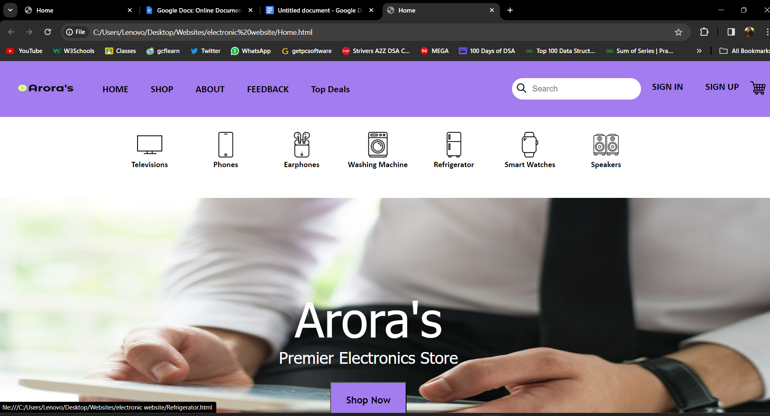

The page shown above is the **HOME PAGE** of the website, you can see the Logo of the website which says “Arora’s” i.e also the title of the website. The website has been given a purple and black theme.

On the top the user can see the **NAVIGATION PANEL** i.e the header, which is helpful in browsing throughout different pages in the website.

There are different options available on the navigation panel like “Home”, “Shop”, “About”, “Feedback”, “Sign In”, “Sign UP”, “THE SEARCH BAR”, “CART”, etc. as you can see in the above screenshot.

After the navigation panel, Come the posters for our trending products. These products are the latest and are selected on the basis of sales and style by our experts.

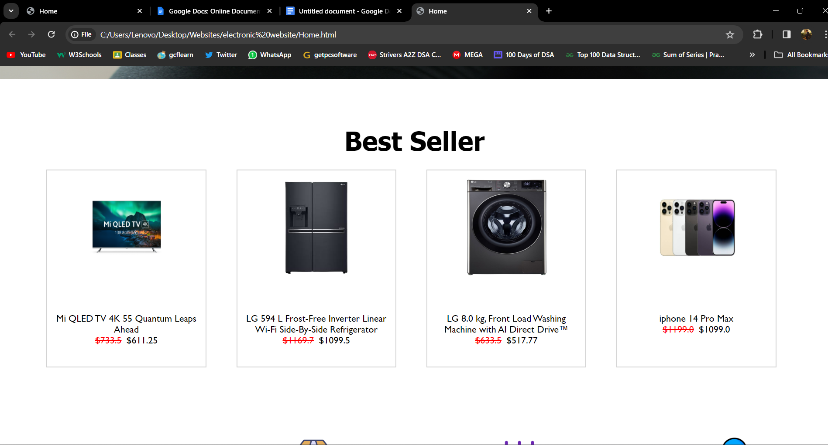

Then comes the **SHOP BY CATEGORY** section of the Home page. Where diverse products are there for the users so they can navigate easily to specific products page.

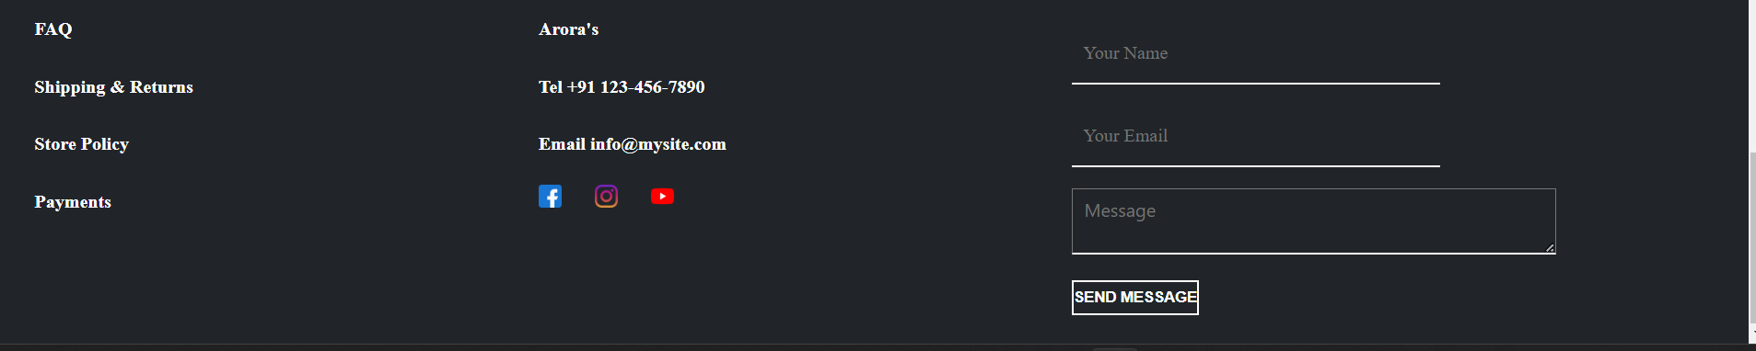

In the last we have the **FOOTER** of the website which consist of copyright notice, social media icons, option for subscribing to our newsletter through e-mail, link to terms and conditions, icons of social media handles etc.

**SIGN IN Page**

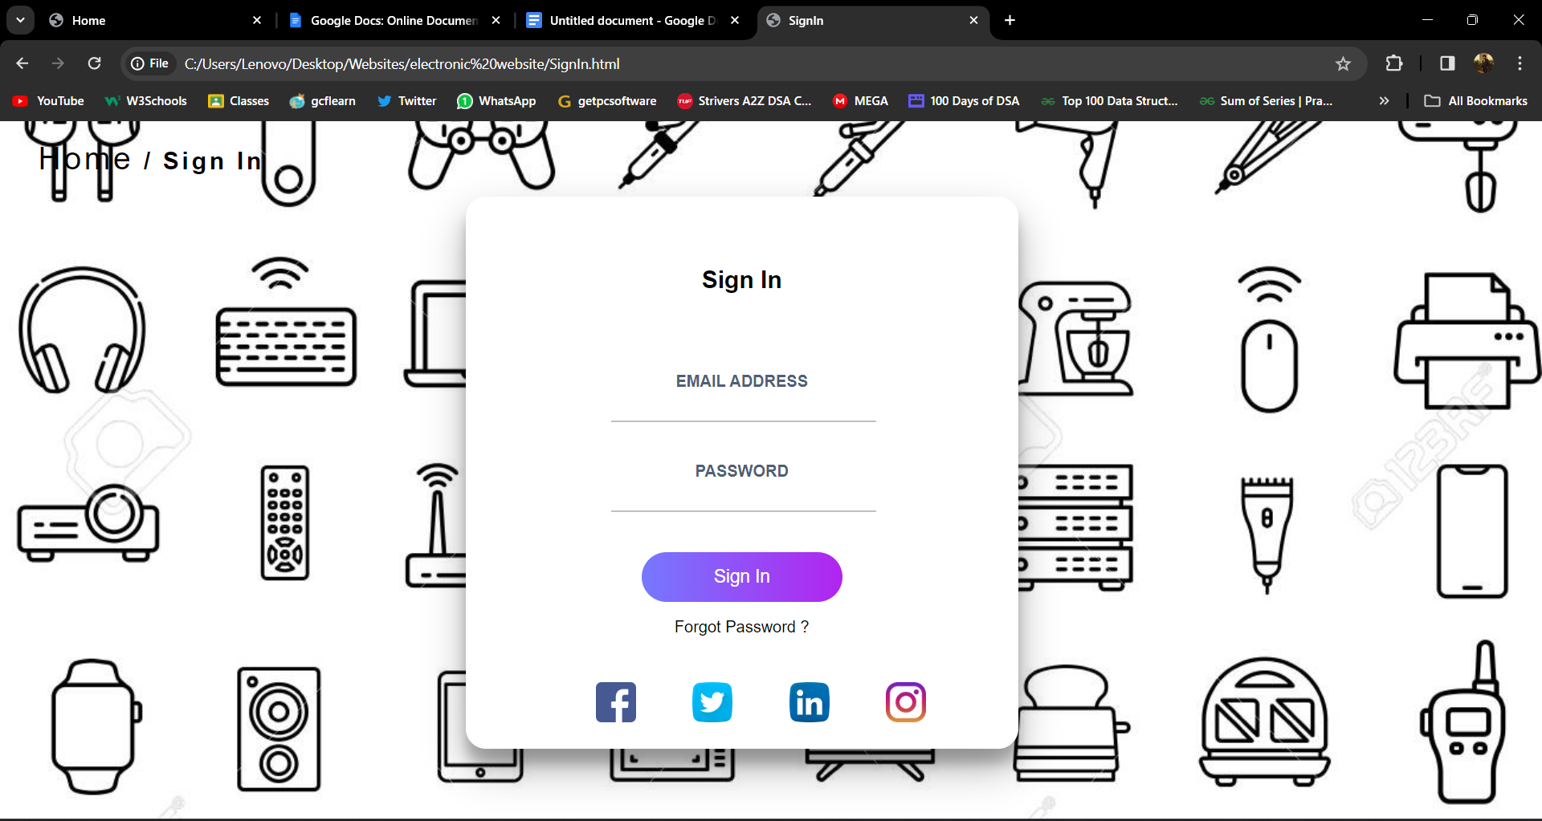

This is the **LOGIN PAGE/SIGN IN PAGE** of the website where users can Login to their GOOGLE account by using their e-mail id and password. The users can also Login using LINKEDIN and Facebook accounts. Also if a user doesn’t have an account in “GOOGLE”, then the user can sign up by clicking on “Sign Up ” on the navigation bar which will land the user to the **SIGN UP PAGE**.

**SIGN UP PAGE**

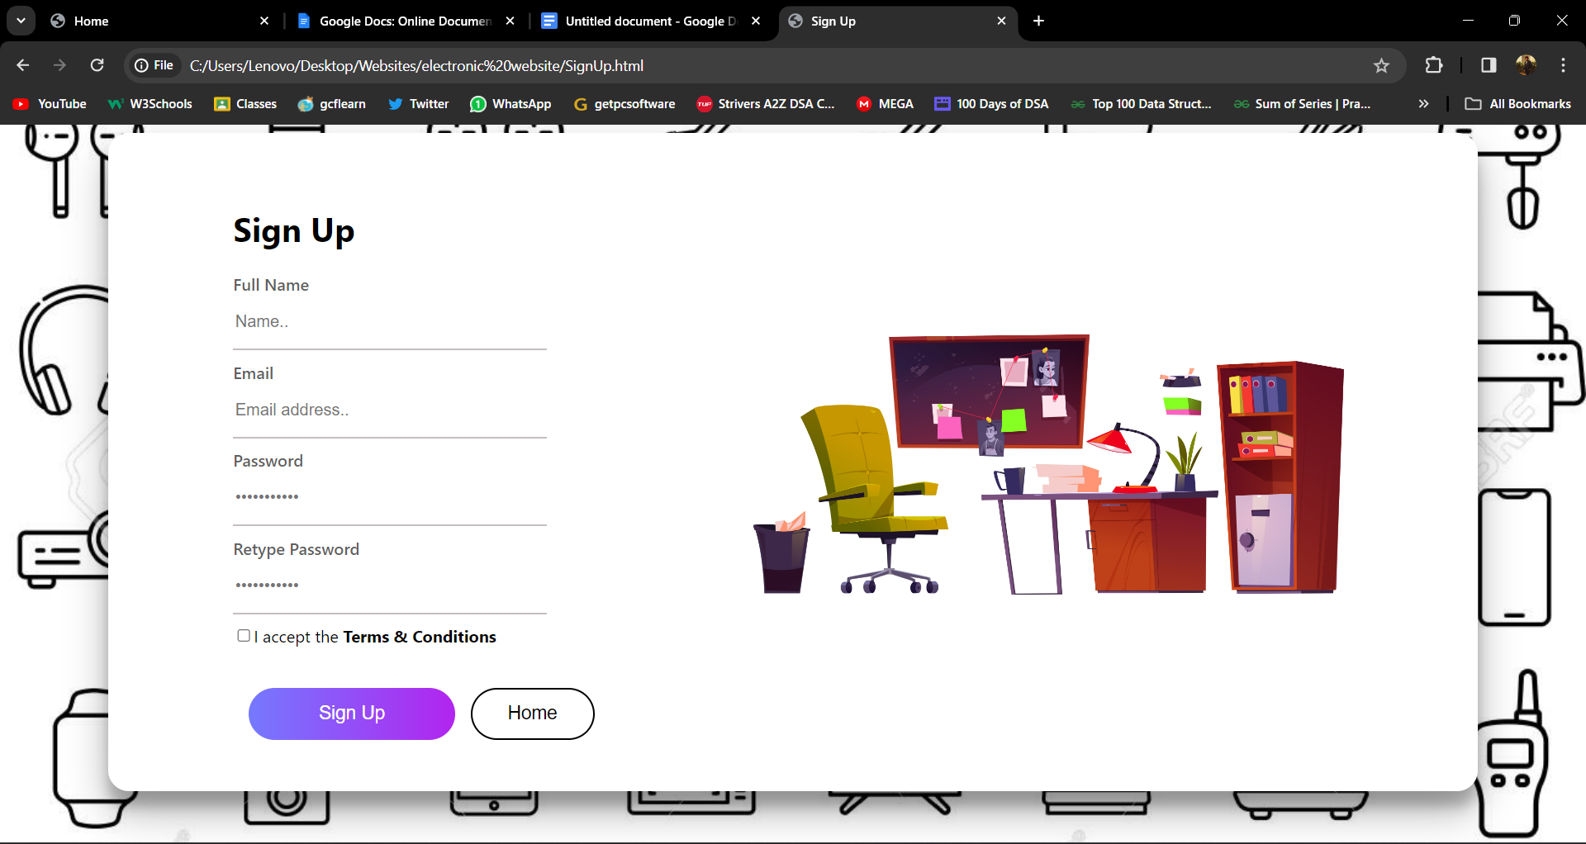

This is the **SIGN UP PAGE** of the website where users can register themselves on “Arora’s” by providing us with their personal details such as first name, e-mail id and the password they would like to choose for their account. The users can also register via their Google and Facebook accounts.

Also the user can return to the **LOGIN PAGE** by clicking on “Sign Up” button.

**TV Category Page**

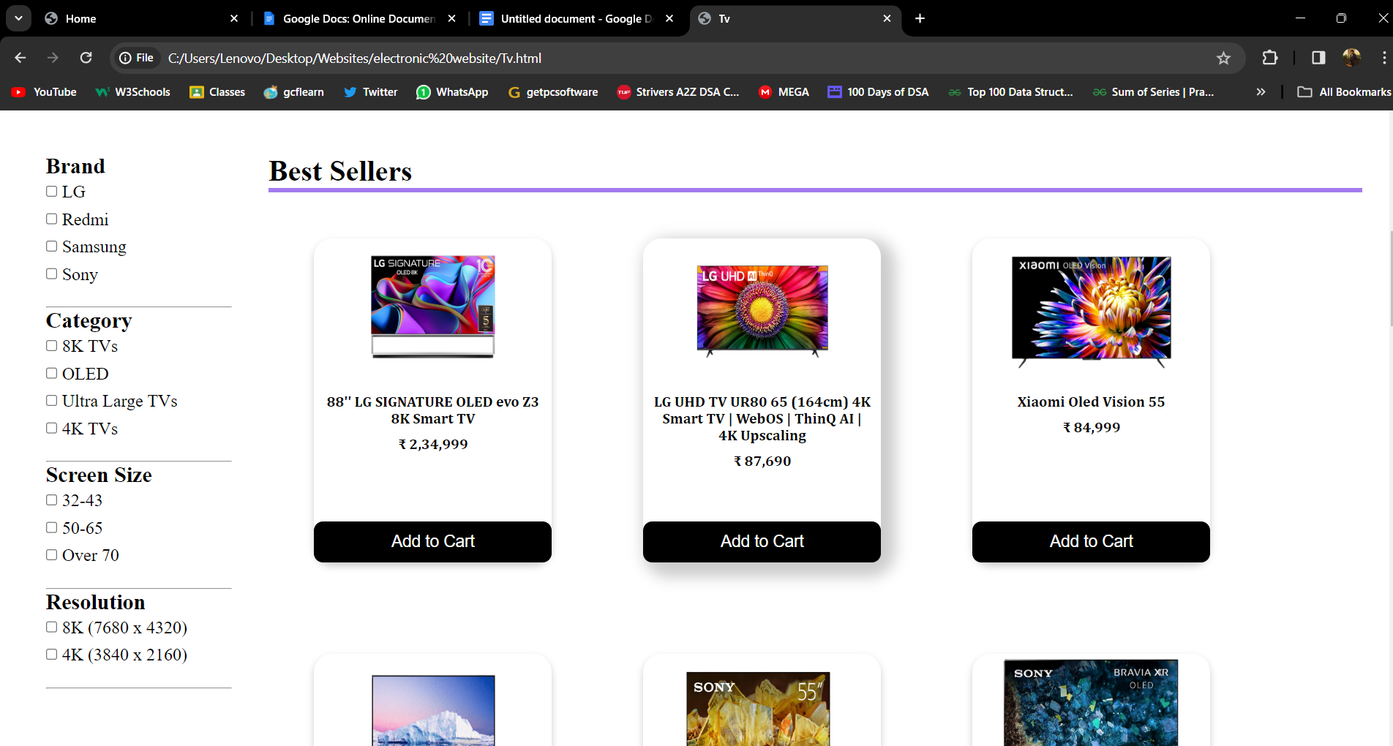

This is Tv’s category page where the products have been sorted for customers. Also every category page has been provided with a filter section on the left where the customer can choose personalized products such Sneakers or Apparels, the user can choose a specific brand or other details. The user can even get the list of the products available in a specific screen sizes. All the sizes are given in the filter section. Further the use can sort products of a particular price range. For e.g. by clicking on the Brand the user gets list of products according to the brands.

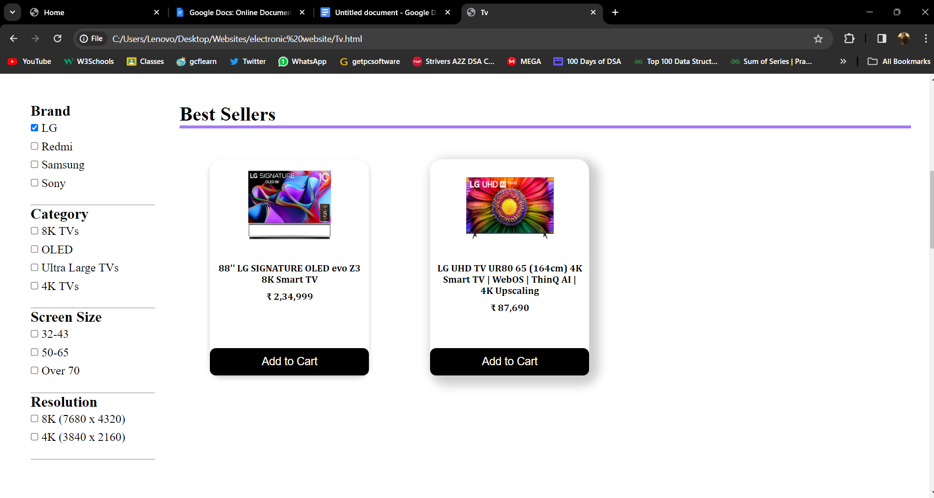

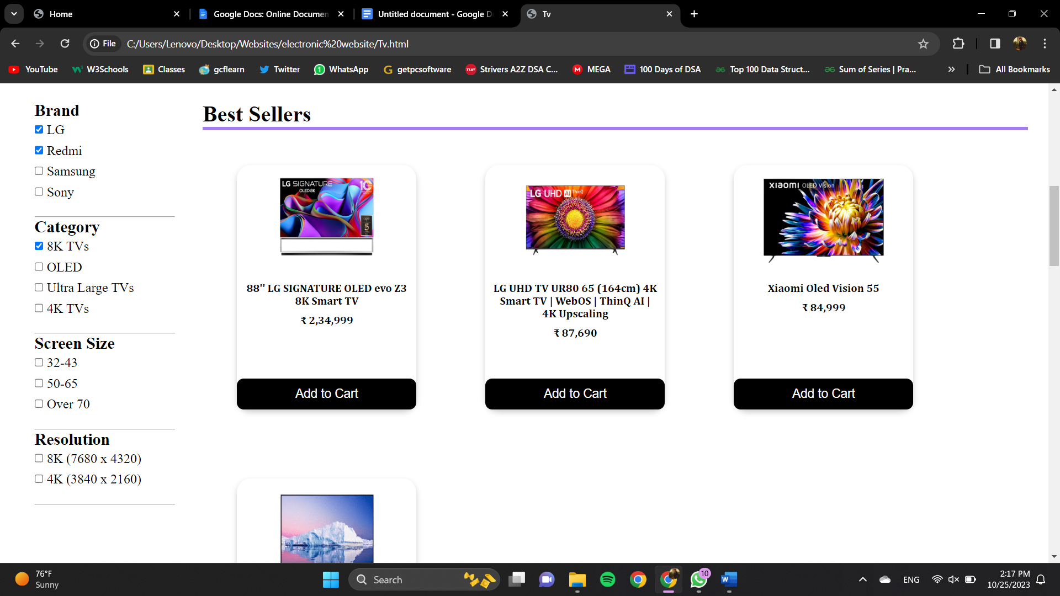

I have created the Shop By Brand Page of Boat and link it with Earphones category page.

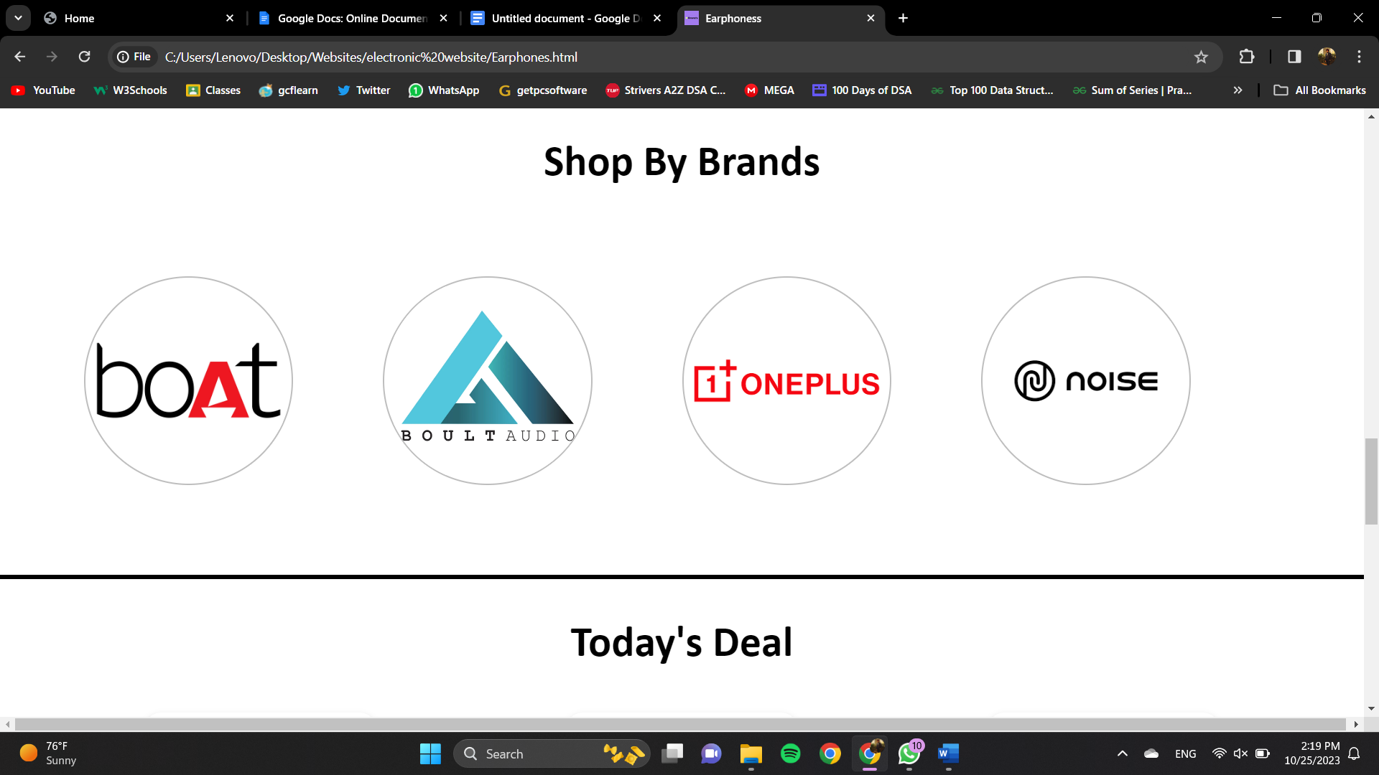

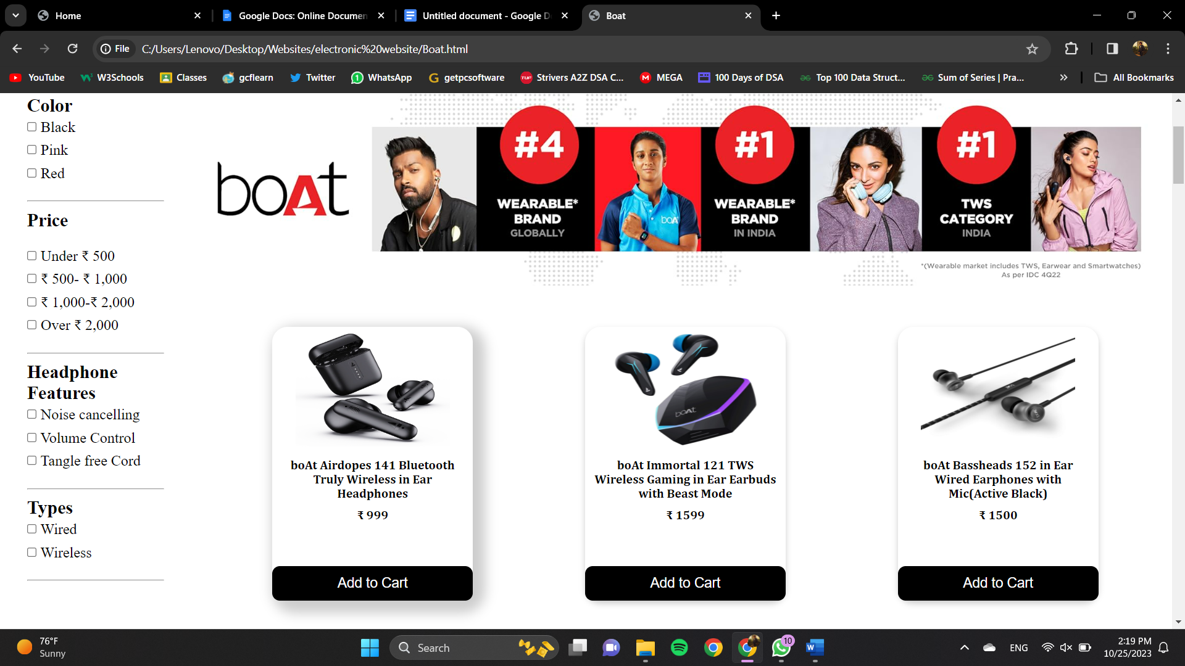

At the bottom of the page, I have added the Boat Cinematic shots and some details so that customer get attracted.

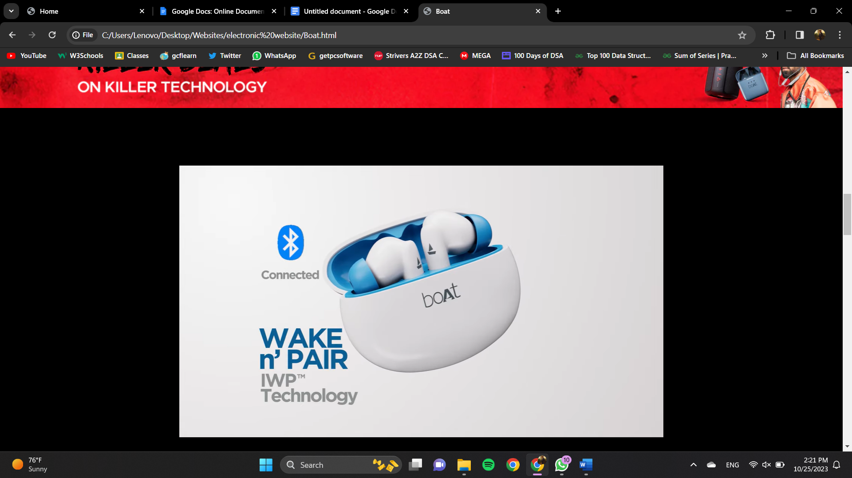

Also I have added Bestseller in Boat Products and I have added some Javascript to make it working.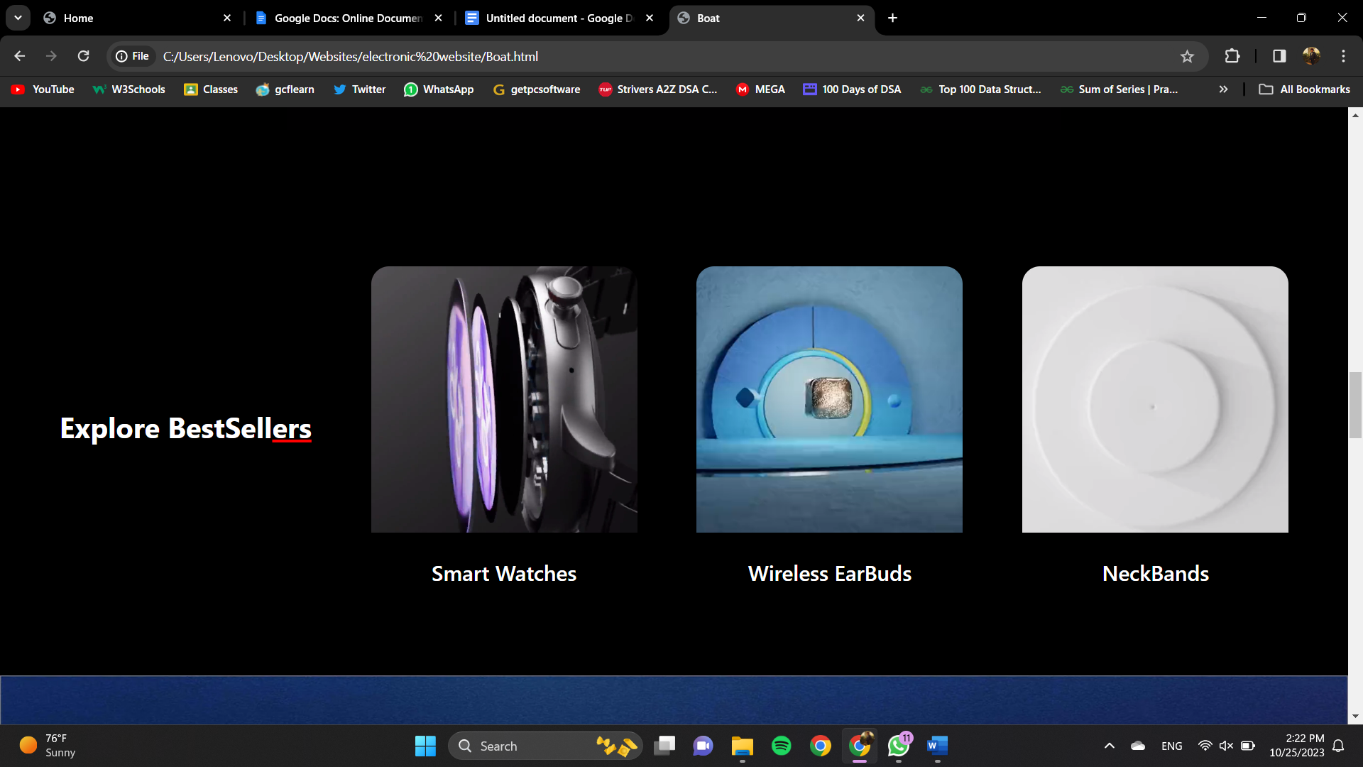

**All Product Pages**

**Refrigerator Page**

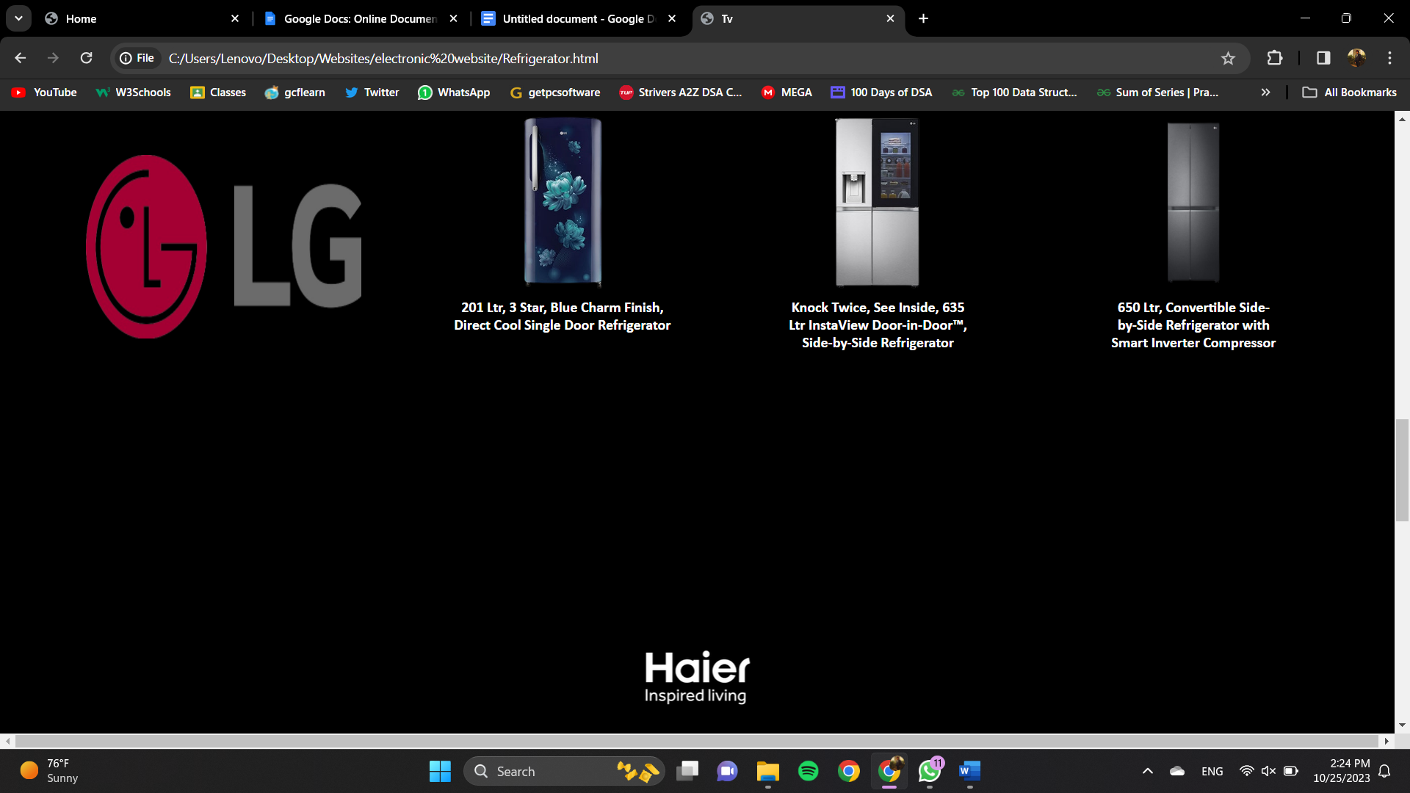

**Smartphone Page**

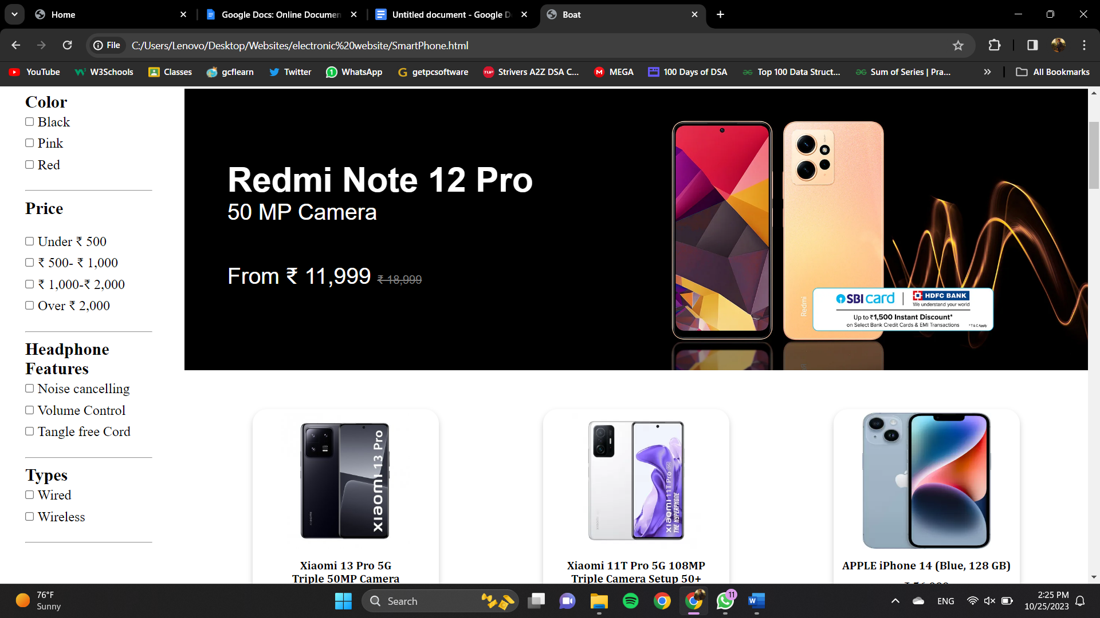

**TV Category Pages**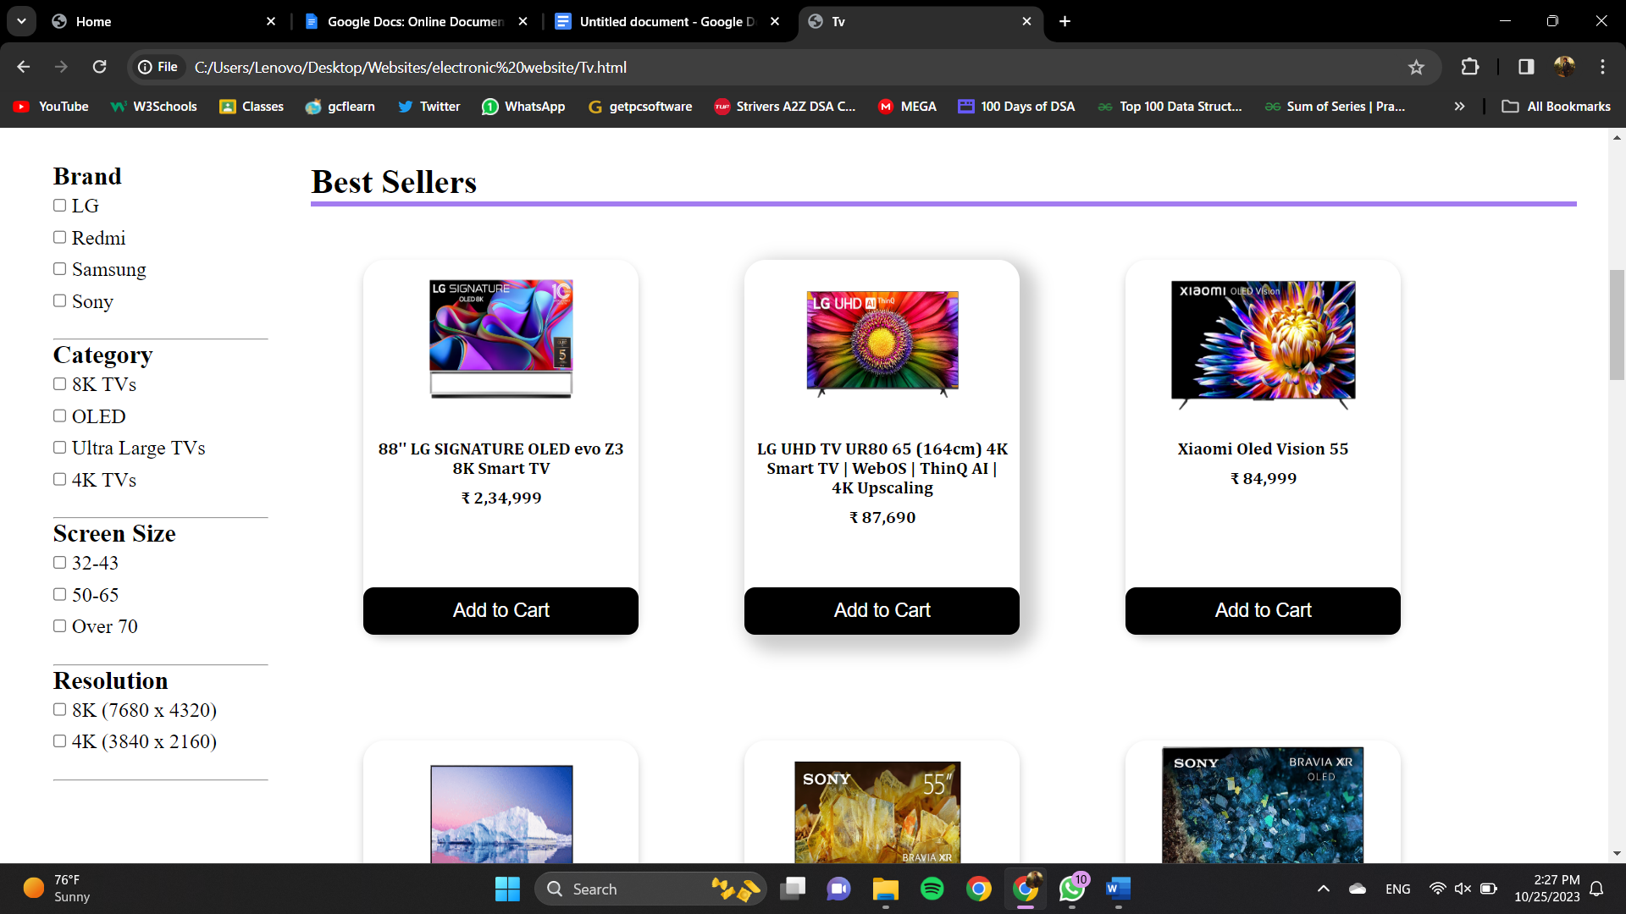

These are some Product Category pages that I have created Using HTML,CSS and Javascript.

In these pages, I faced challenges in designing of the Page.

So, I explore on the internet and get some ideas from the pre-existing templates.

Now the user or customer can also give us reviews and feedback so we can improve and overcome the drawbacks.

So, I have provided Feedback webpage as you can see in Navigation bar

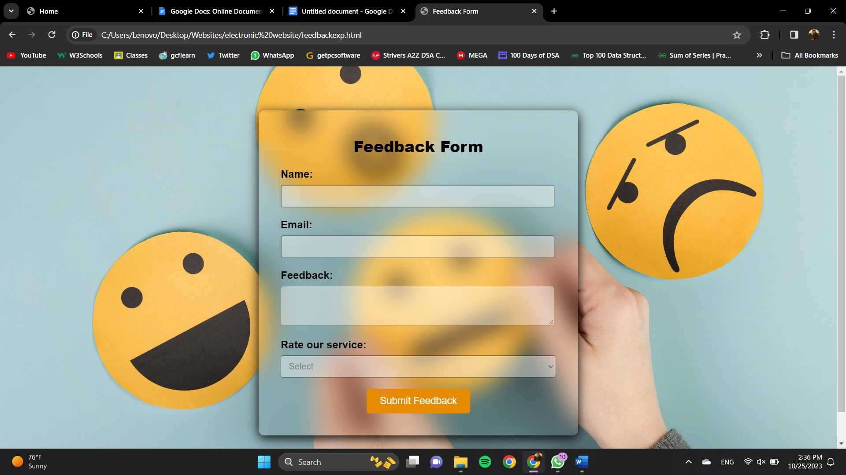

This is the Feedback page which consist of a form, which can be filled by the user if he/she has any complaints regarding the website or any product. If the user wishes to visit our help center then he/she can click on the help center button and get the address of the nearest help center.

Below are Screenshots for the **ABOUT US PAGE**

**ABOUT US Page**

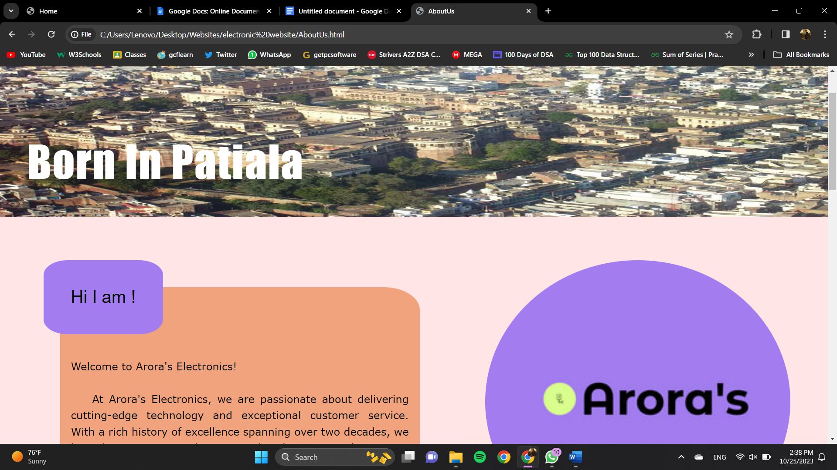

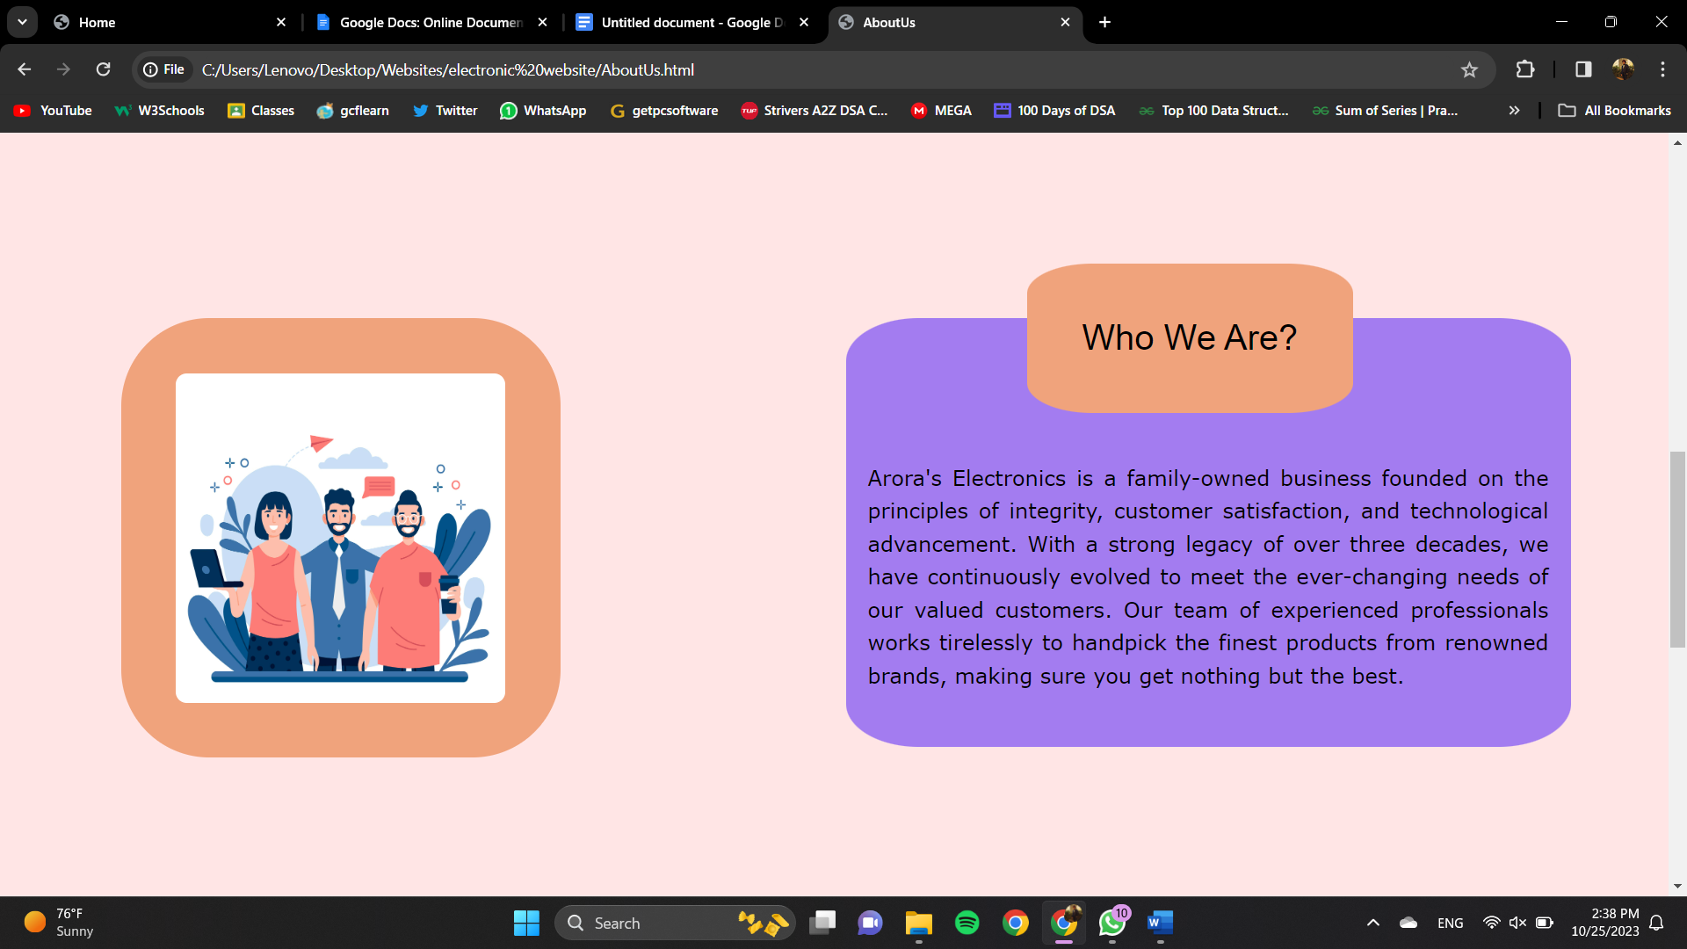

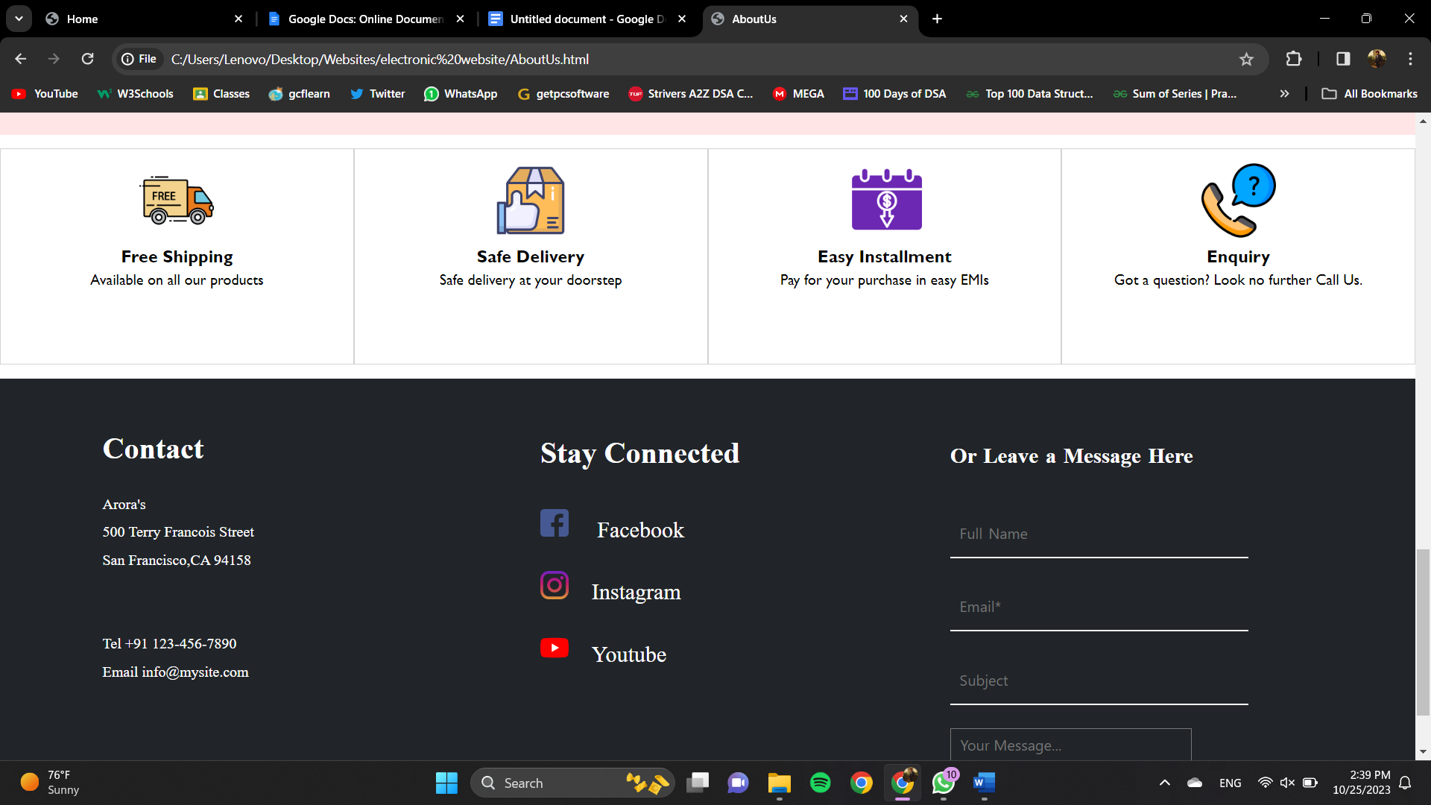

I have added the Cart option, when user click on **Add To Cart** button on products card the product gets added to the cart. When we click on the cart image present on navigation bar, it jumps to the cart section present at the end of the Page.

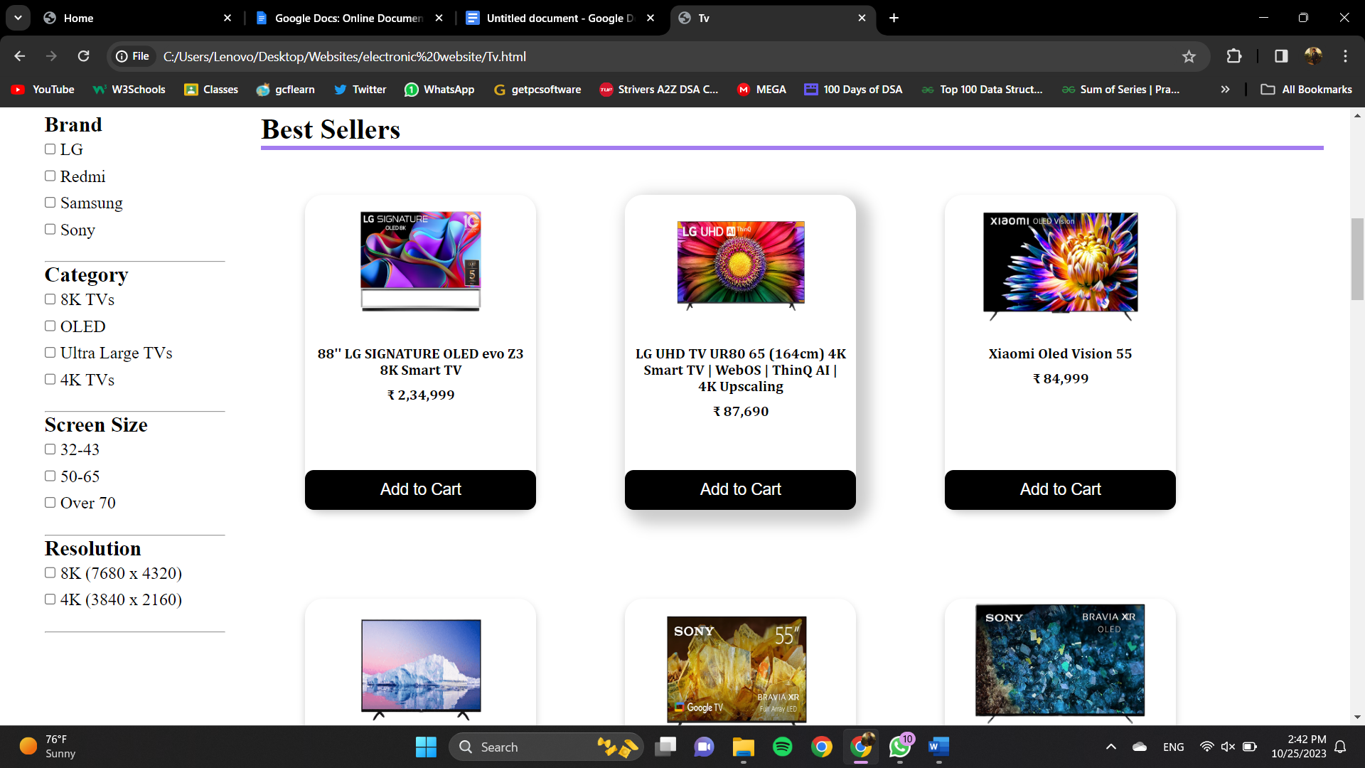 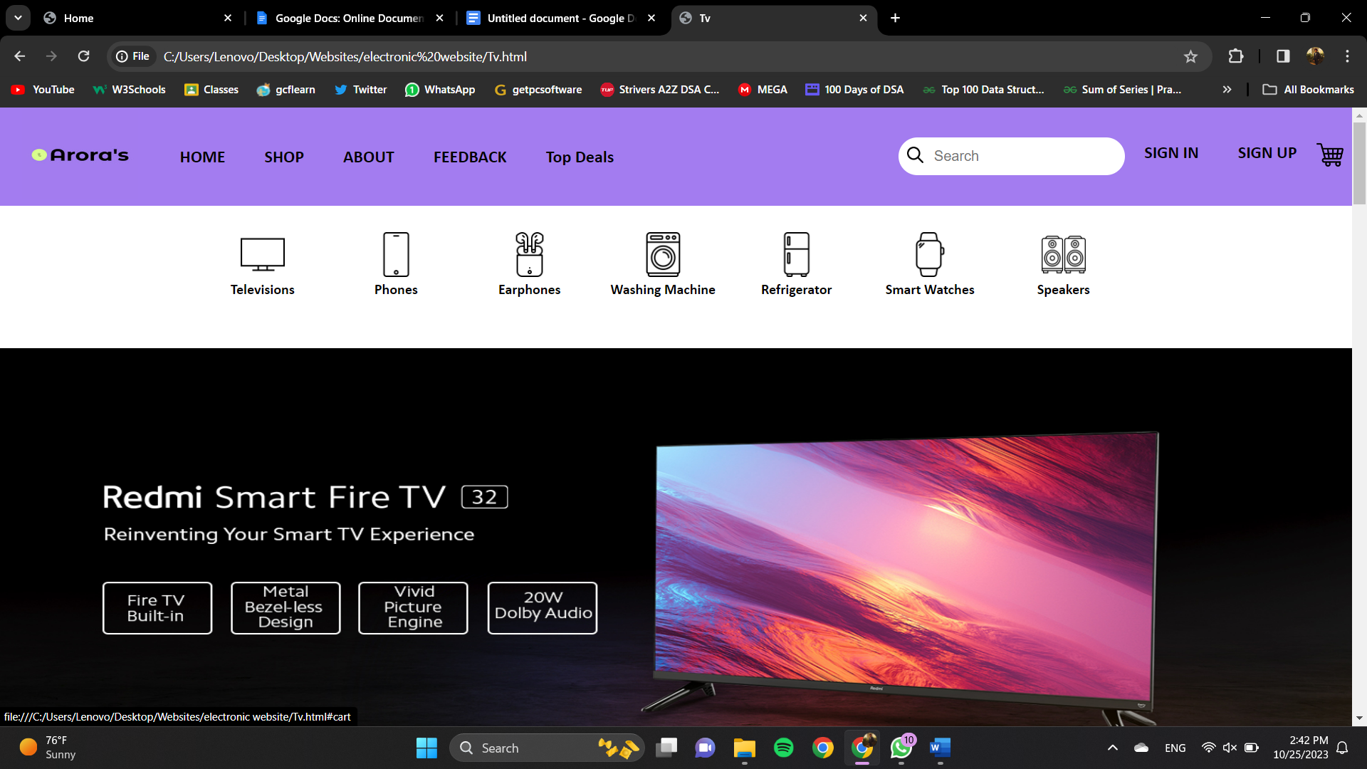

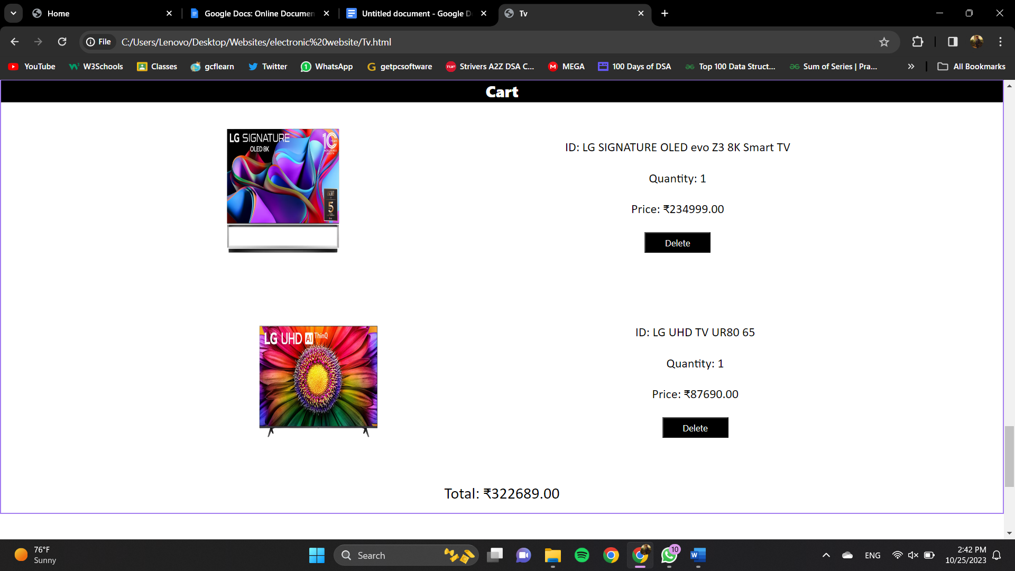

This is **CART** of the website, whenever a person wishes to buy a product, it is added to the cart, the total quantity and the total price of the products are mentioned in the bottom and there is an option to enter the coupon code no., if the user has any....

Further the can checkout and pay for products in the payment section.

In the Cart Section you can remove the product from cart and after that click on **Click To Pay** button present below the cart section you will get jump into the **secured payment** page.

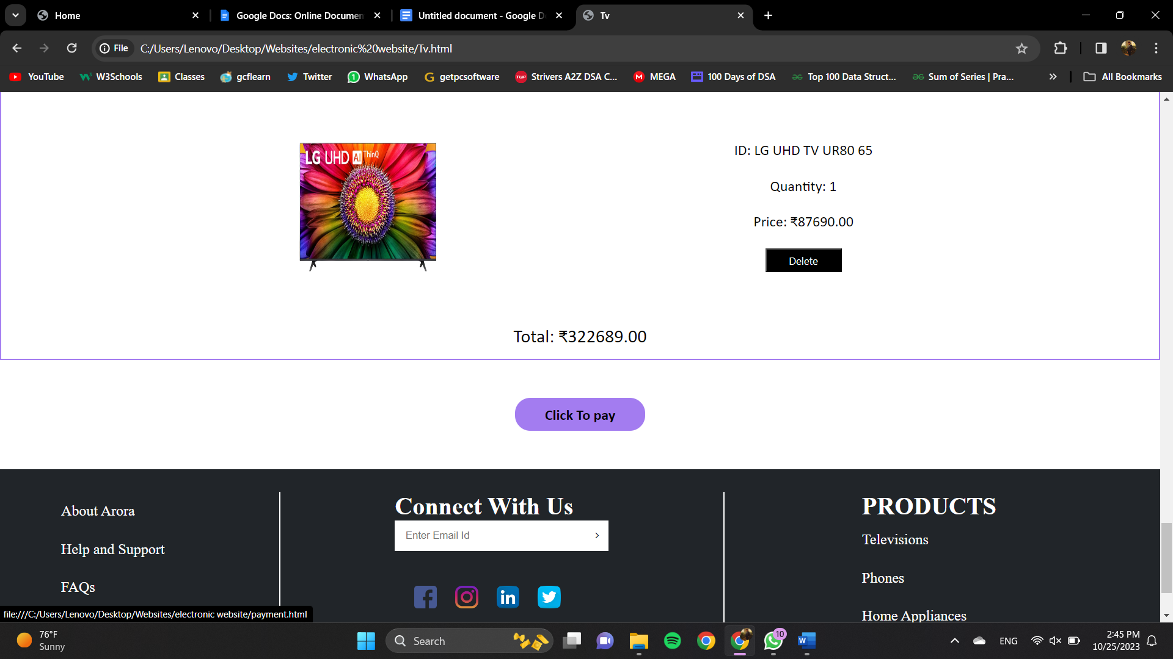

**PAYMENT PAGE**

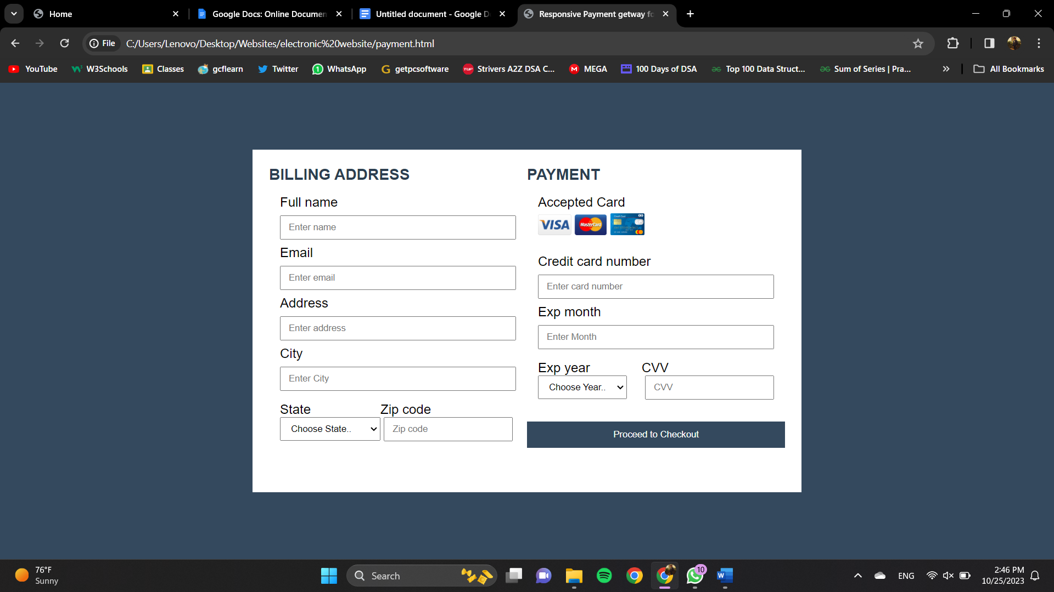

After clicking the checkout/buy now button the user lands on the shipping details page. The can here enter his/her address and contact number where they want the product to be delivered and then continue to payment gateway.

This is **PAYMENT GATEWAY PAGE**

The Card details are entered by the user and the payment will be successful. If this page is submitted without entering anything then it would show invalid input and the user has to enter the details in order to complete the order.

**PRODUCT PAGES**

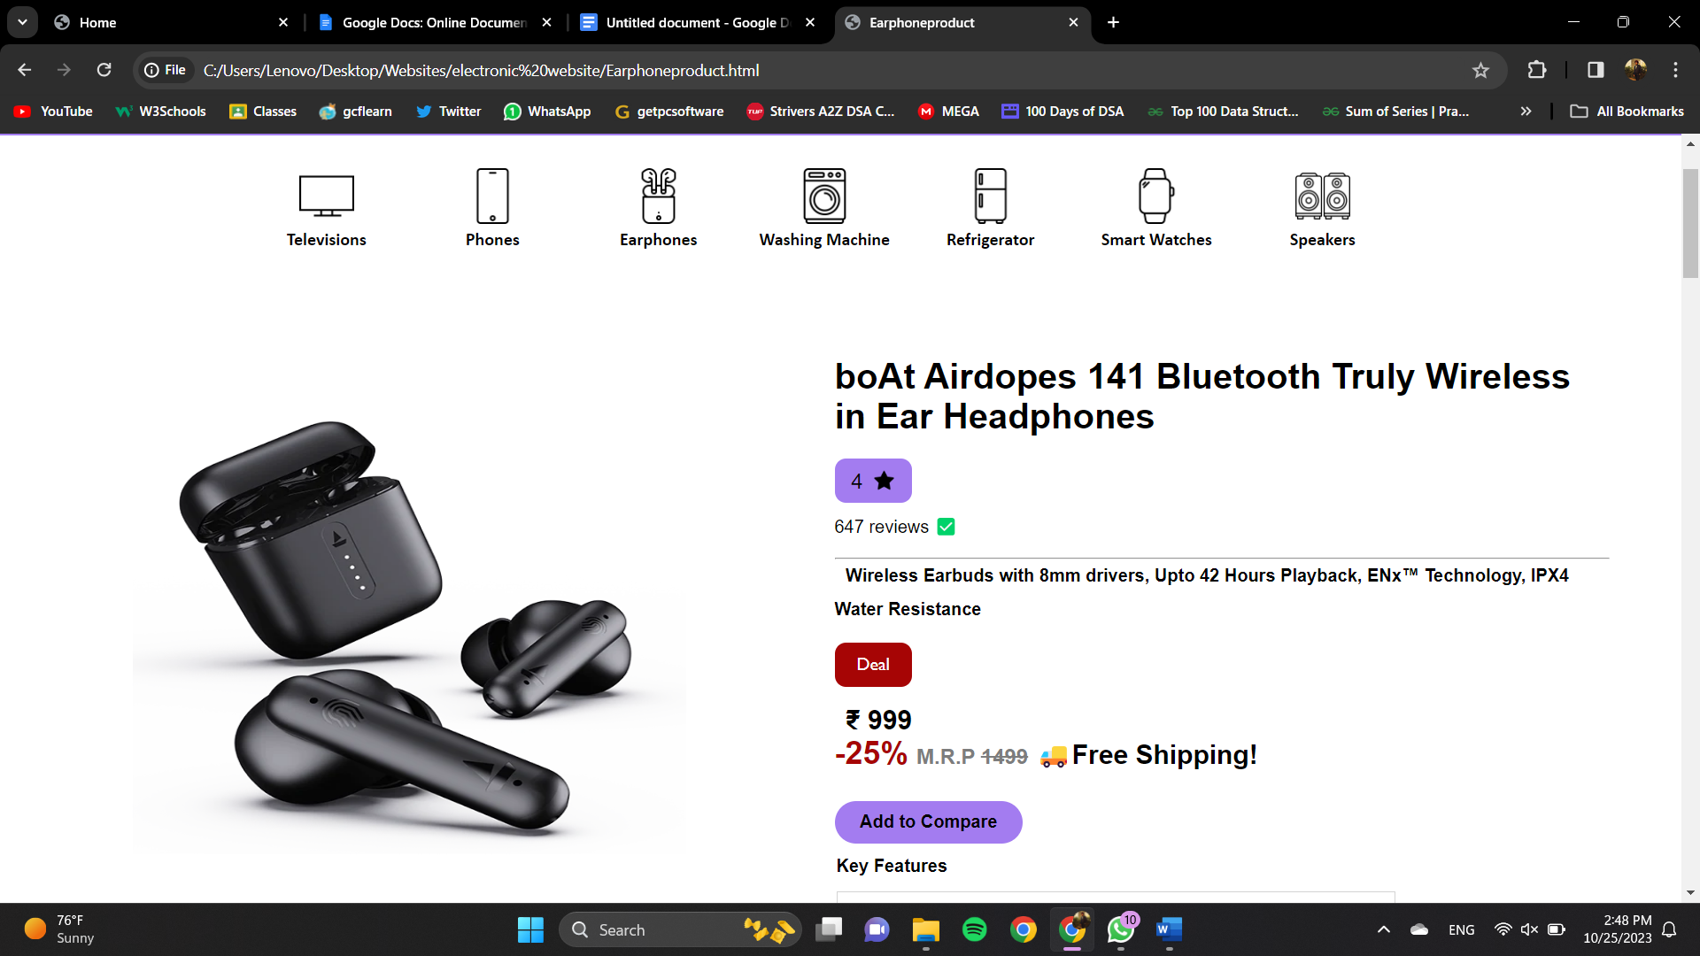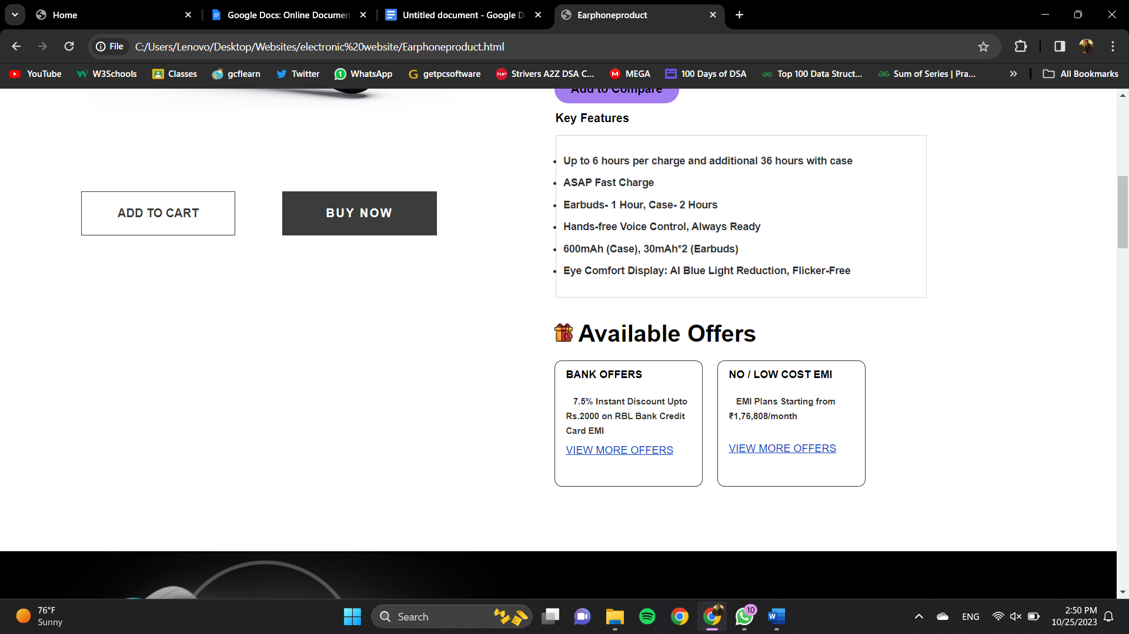 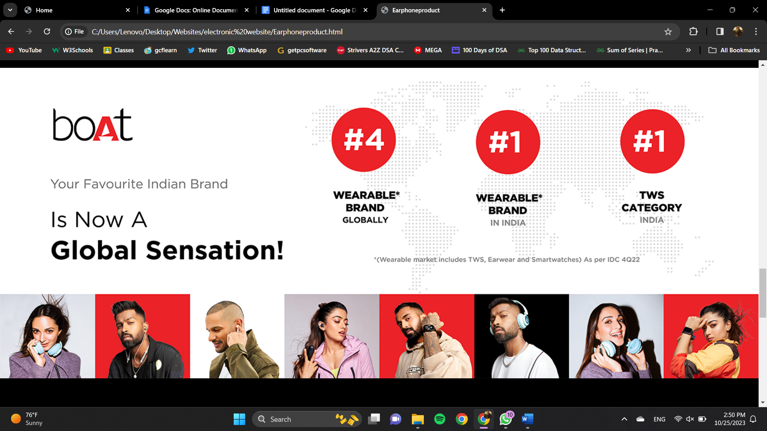 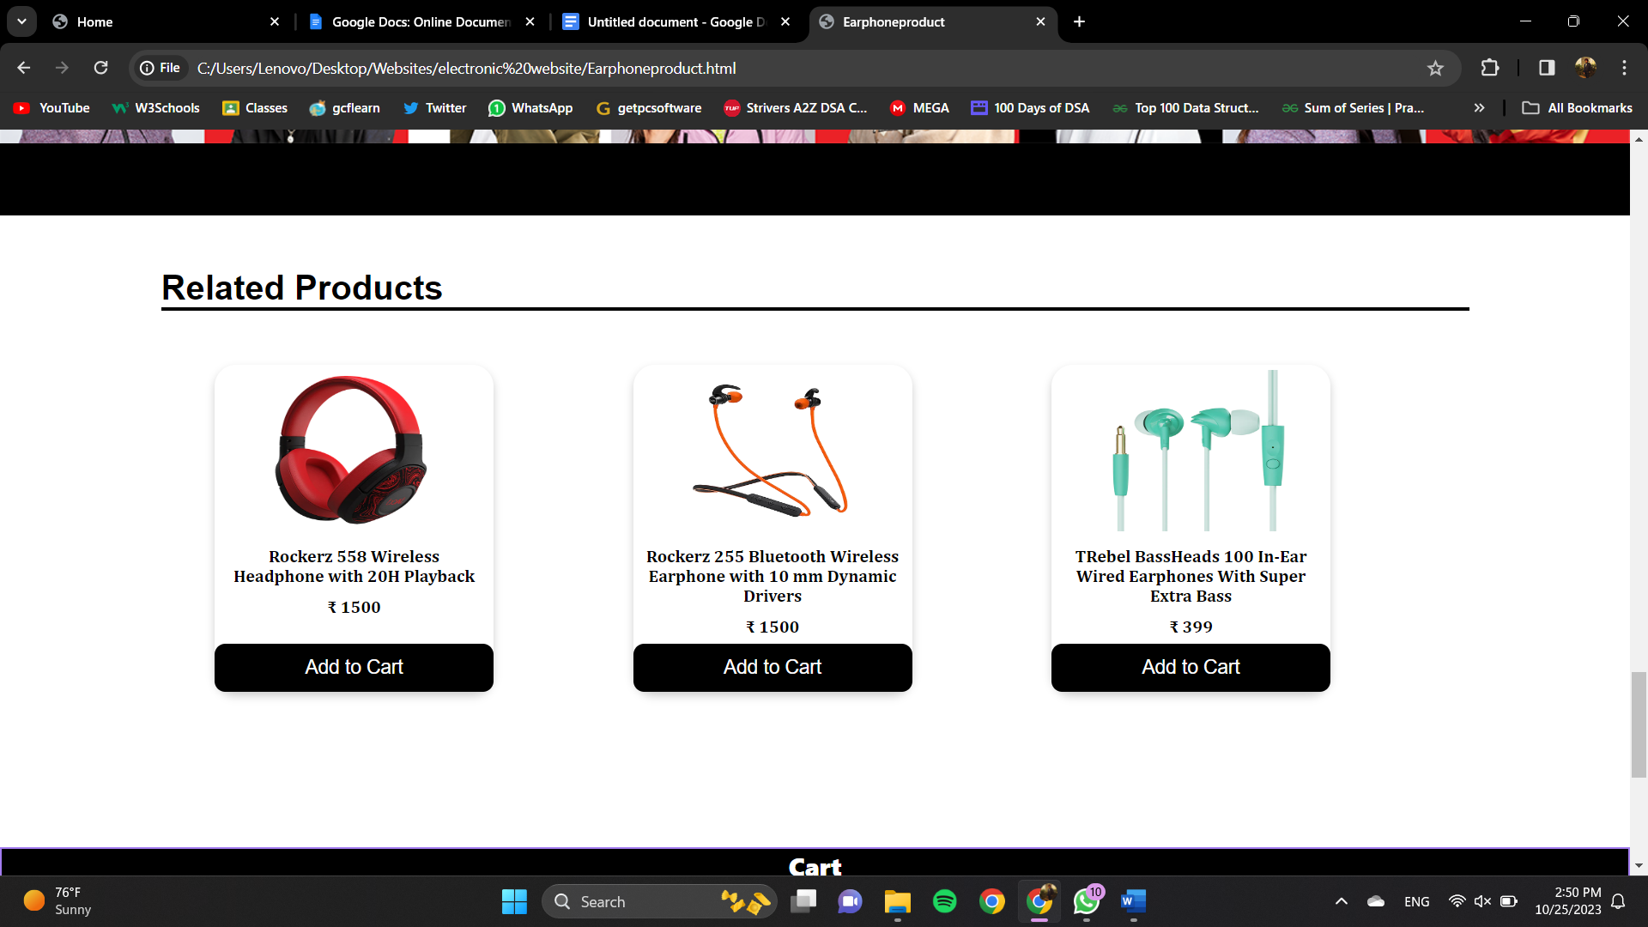

This is **PRODUCT DETAILS PAGE** of the website where every detail of a product is mentioned like the price, product type, brand, product name, manufacturer details, origin, article code are given.

After then there is a section where **PRODUCTS YOU MAY ALSO LIKE** are listed.

**Top Deals Page**

For the people who are curious about offers and deals ,they can get all the offers and deals on one page known as **Top Deal page** present on the navigation bar. 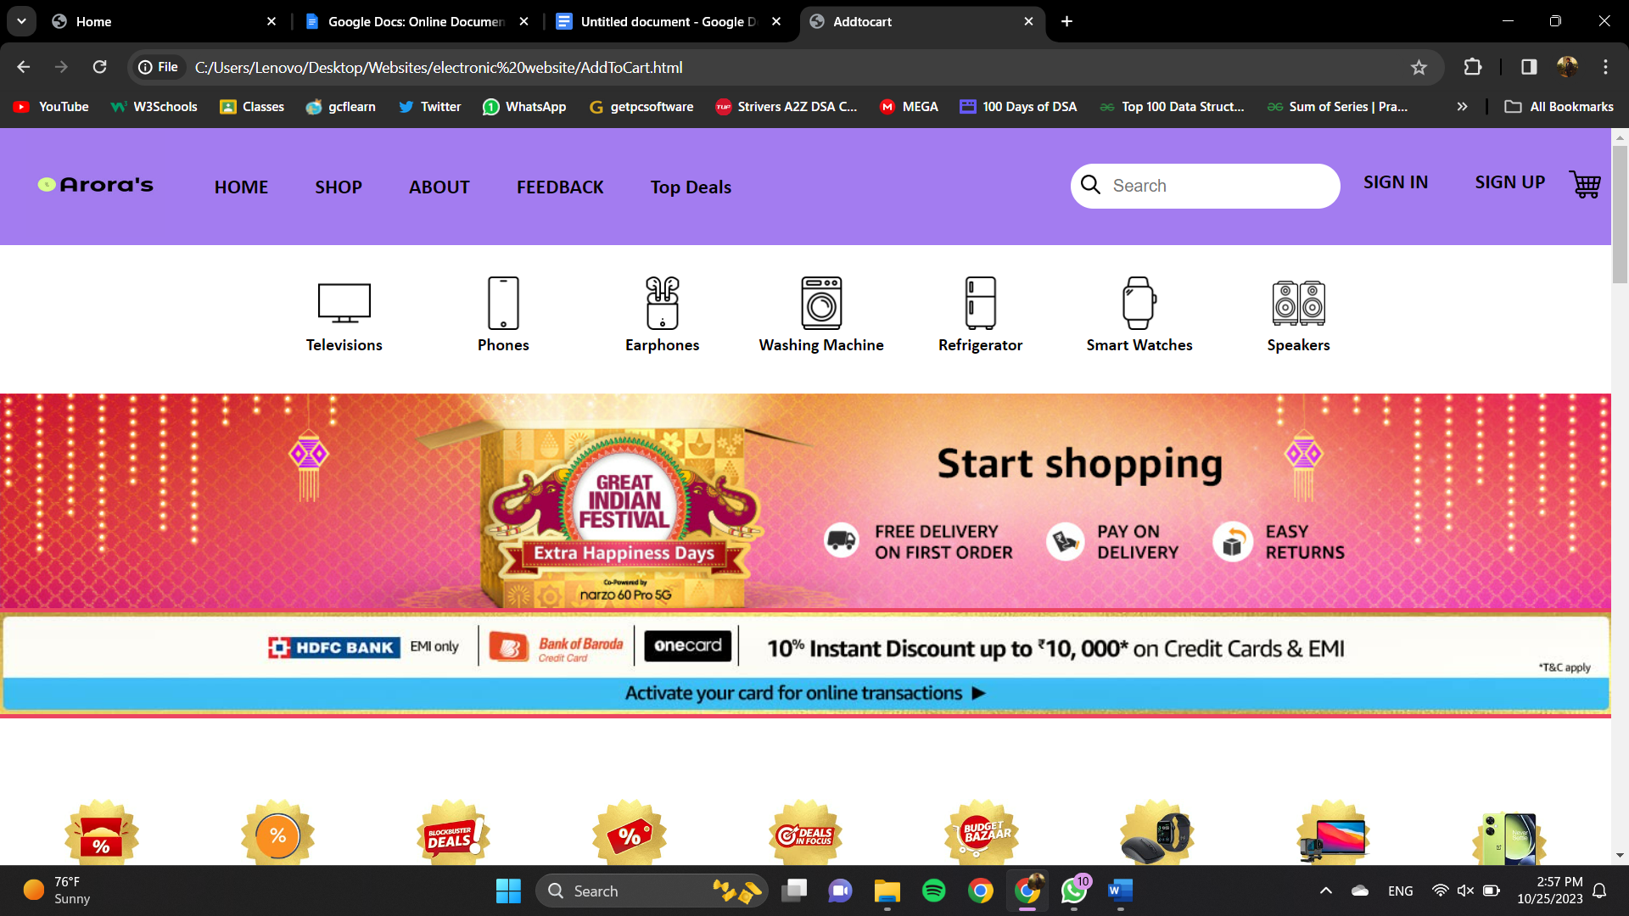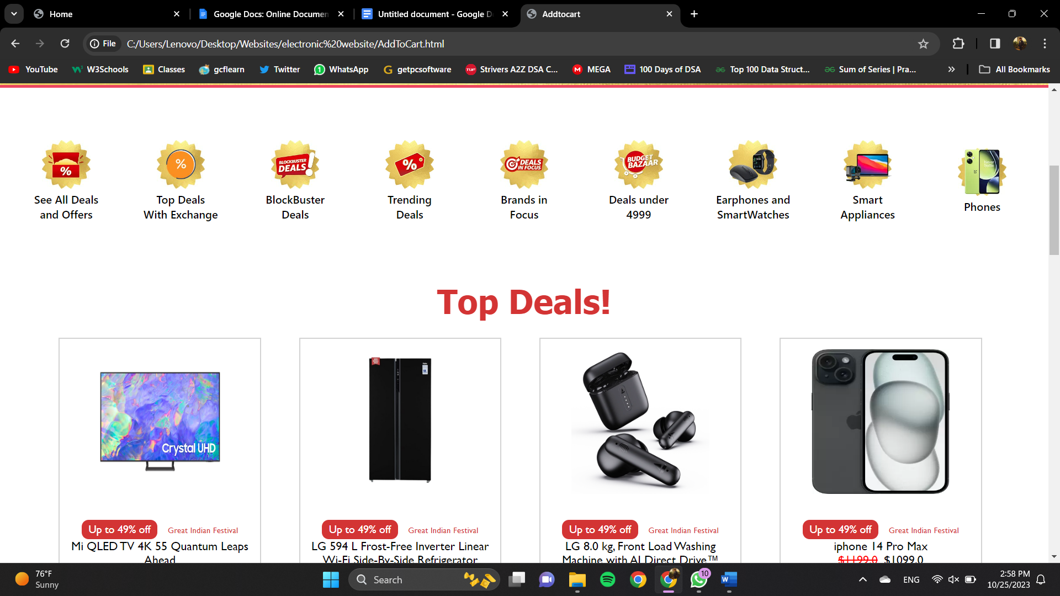

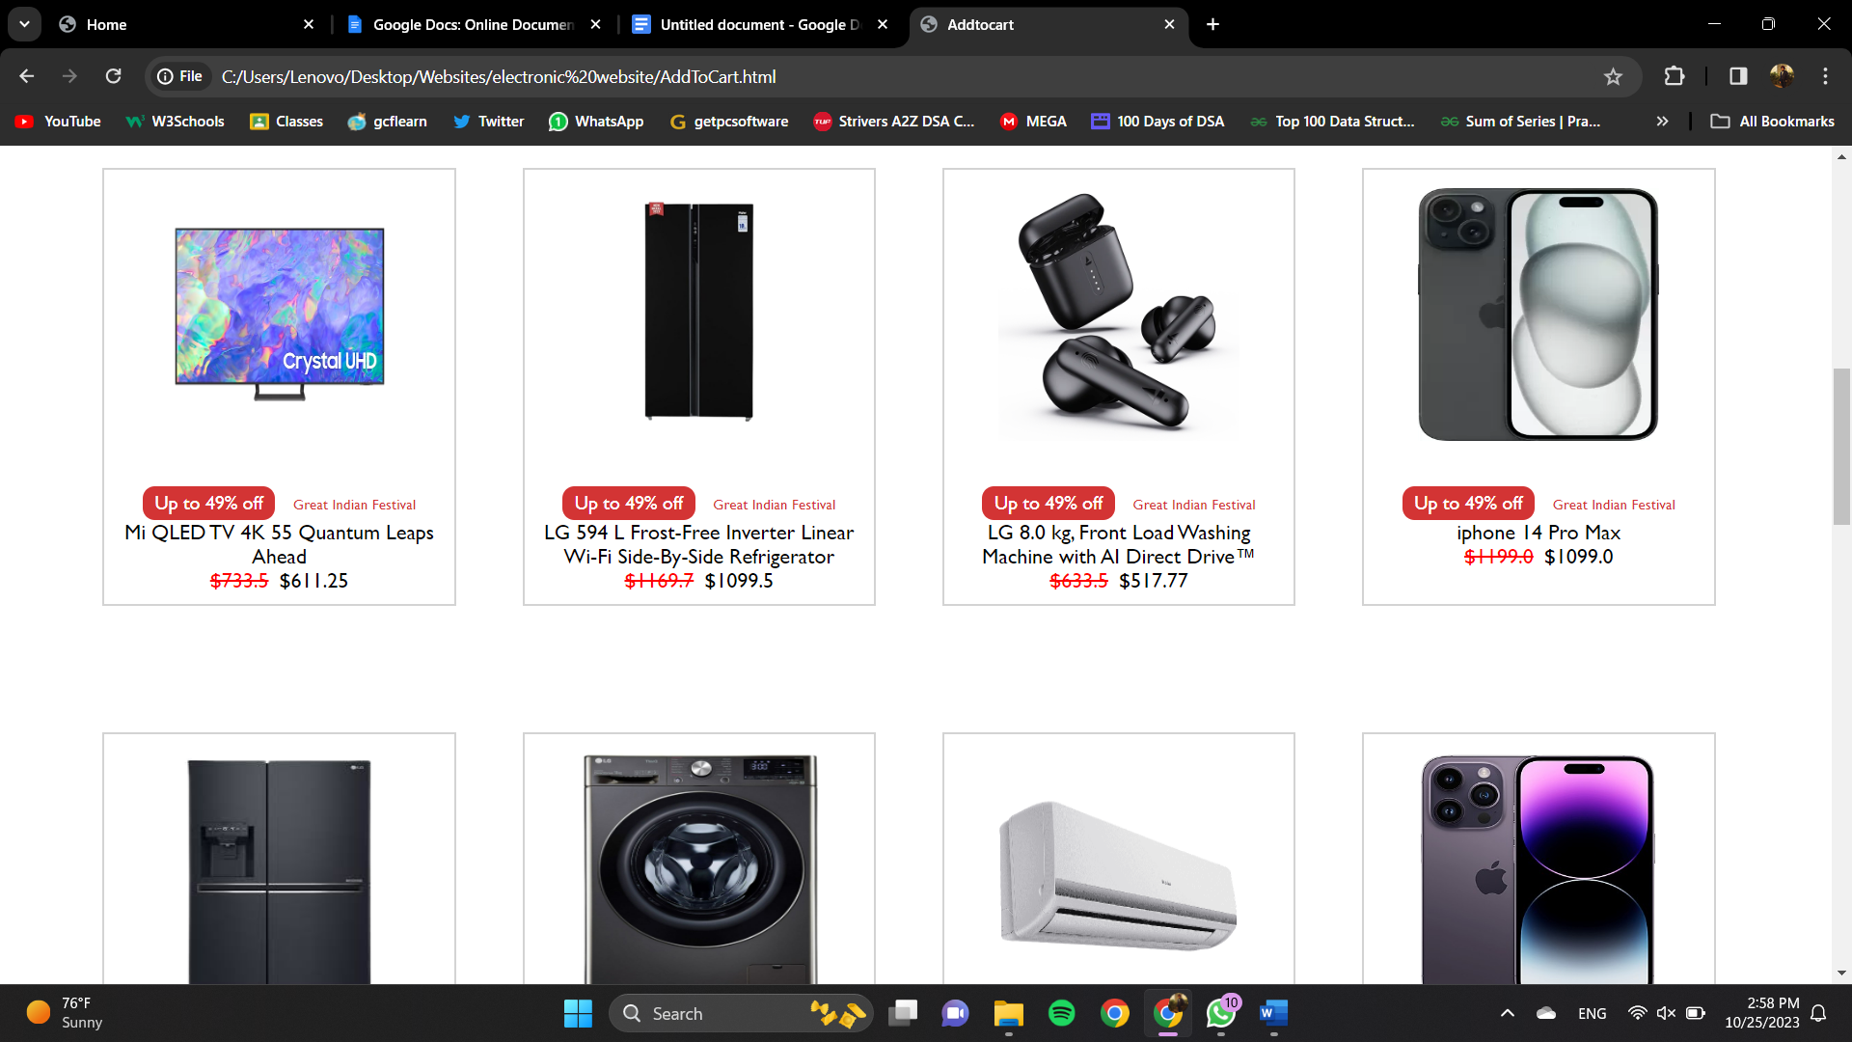

User can get all the the offers and deals product in one page.

During making of the project ,I faced many challenges and consequences that result in enhancing my front-end skills.

**8. Conclusion with Future scope**

**8.1 Conclusion of the Project**

The Electronics Website is a simple and modern website that promotes and markets shoes. The webpage uses HTML, CSS and JAVASCRIPT technologies to structure and style the content of the webpage. The webpage is fully responsive and accessible on different devices and screen sizes. The project code is well-structured, organized, and easy to maintain.

Overall, the project was successful in achieving its objectives and provides a high-quality user experience. The project's advantages include increasing brand awareness, generating leads and conversions, and improving customer engagement. In the future, the project could be further developed to include additional features such as interactive product demos or customer testimonials, which would further enhance the user experience and drive sales.

**8.2 Future Scope:**

The future scope of the product landing page project could be to further enhance its functionality and user experience. Another possible improvement could be to making it easier for potential customers to find the product through online searches and a customize feature where users will be able to customize the shoes according to their need. Lastly, incorporating user reviews and ratings on the product page could provide valuable feedback to the company and increase customer trust and satisfaction.